**Partho Choudhury Shoumya**

[](https://www.linkedin.com/in/shoumya-c-883b0a11b/)**[](http://www.github.com/shoumyachoudhury)**BSc. Student of CSE

Passionate computer science student with **5 years** of experience of competitive programming and development in various Online Judges. Enthusiastic about new technologies and loves to think to solve problems.

Experience

**2023 – Present :** Organizing Secretary of SGIPC, KUET.

Responsible for organizing and monitoring various important events of SGIPC, KUET.

**2022 – 2023 :** Workshop Manager at SGIPC, KUET.

* Responsible for arranging topic-wise workshop for junior member of SGIPC, KUET club.
* Responsible for solving doubts about topics taught in each workshop of workshop attendees after each session.

Education

|  |  |
| --- | --- |
| **2019 – Present :** | 4th year student of Computer Science and Engineering of Khulna University of Engineering and Technology. |
| **2016 – 2018 :** | Studied Science from M.C.College, Sylhet and secured GPA 5.0 in HSC examination. |
| **2011 – 2016 :** | Studied High School subjects in Sylhet Govt. Pilot High School, Sylhet |

Technical Skills

* Proficient in data structures and algorithms.
* Fluent in C++, Python and JavaScript.
* Experienced in ReactJS, NodeJS and MERN stack

Communication Skills

* Fluent in Bangla
* Good in English
* Comfortable in understanding basic Hindi.

Projects

|  |  |
| --- | --- |
| [**Tuition_Bank**](https://github.com/shoumyachoudhury/Tuition_Bank) **:** | A simple android app based on ‘firebase’ database to help students, parents and teachers to communicate in a common platform |
| [**Smart irrigator**](https://github.com/shoumyachoudhury/Smart-irrigator) **:** | A simple Arduino based smart irrigation system that senses the level of water in land and pour water according to that. |

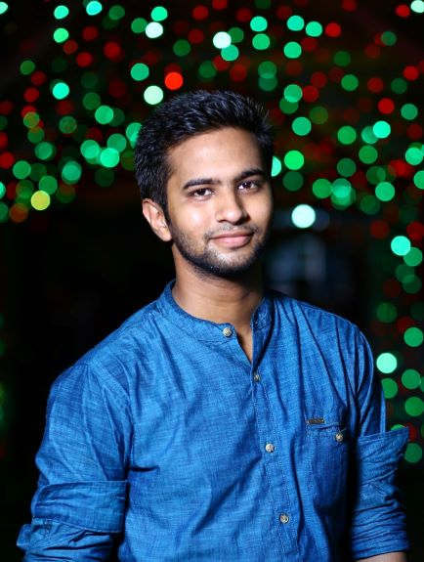

**Personal Information**

**Address**

Fazlul Haque Hall, KUET

**Phone**

+8801750041113

**Email**

[shoumya1807021@stud.kuet.ac.bd](mailto:shoumya1807021@stud.kuet.ac.bd)

**Age**

23

**Nationality**

Bangladeshi

**Marital Status**

Single

**Facebook Profile**

<https://www.facebook.com/Shoumya.C.P>